# How to bind receivers to transmitters

## FRSky Taranis X-Lite S

1. Start with the receiver connected to the battery but TURNED OFF
2. Go to the **SETUP** screen

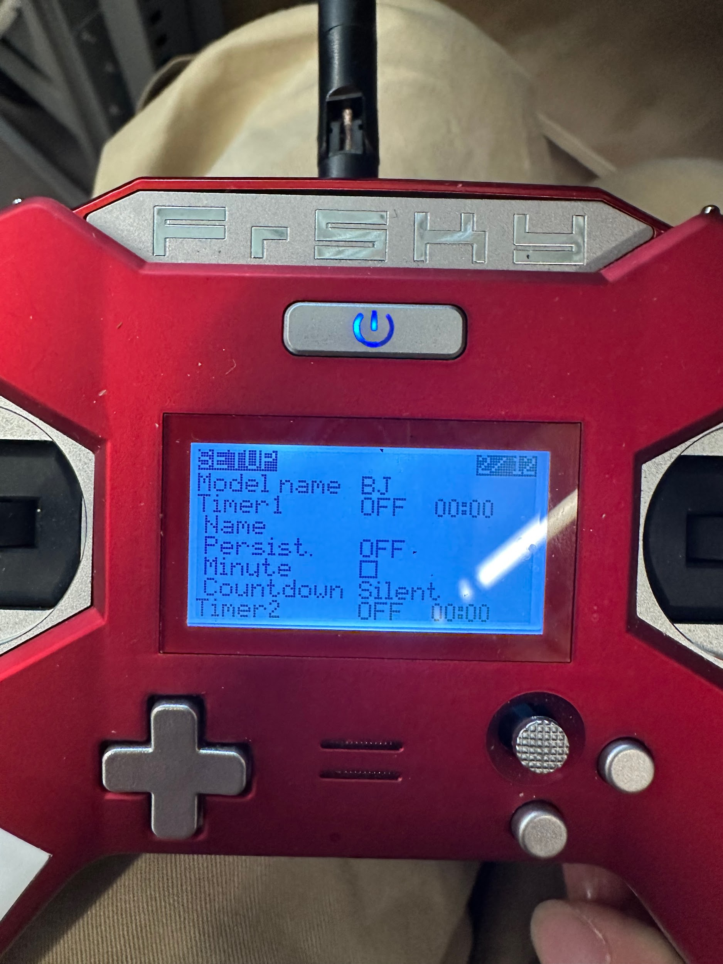

1. Scroll down to **Module**
   1. Select **[Reg]**

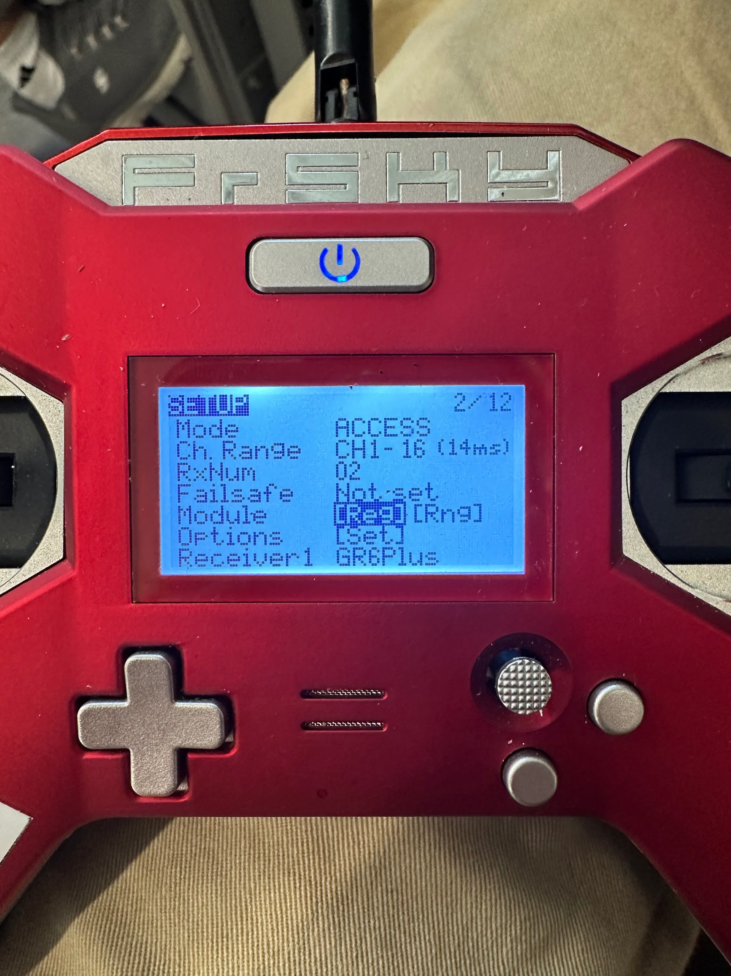

* 1. While the transmitter displays this screen, turn on the receiver WHILE holding down the button on the receiver

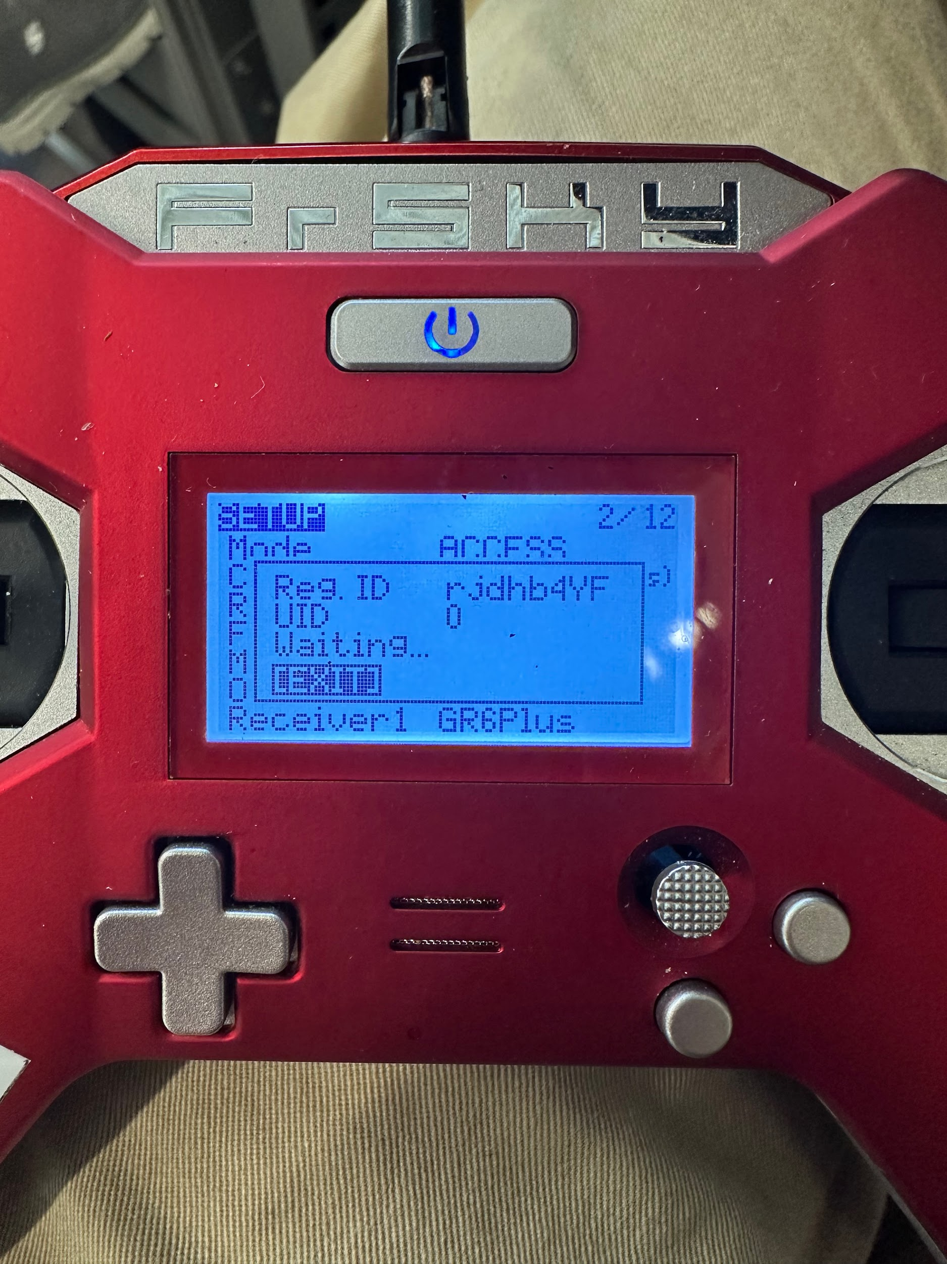

1. The screen should display a “Registration OK” message
   1. Press **[ENTER]**
2. Power off the receiver
3. Scroll to **Receiver 1**

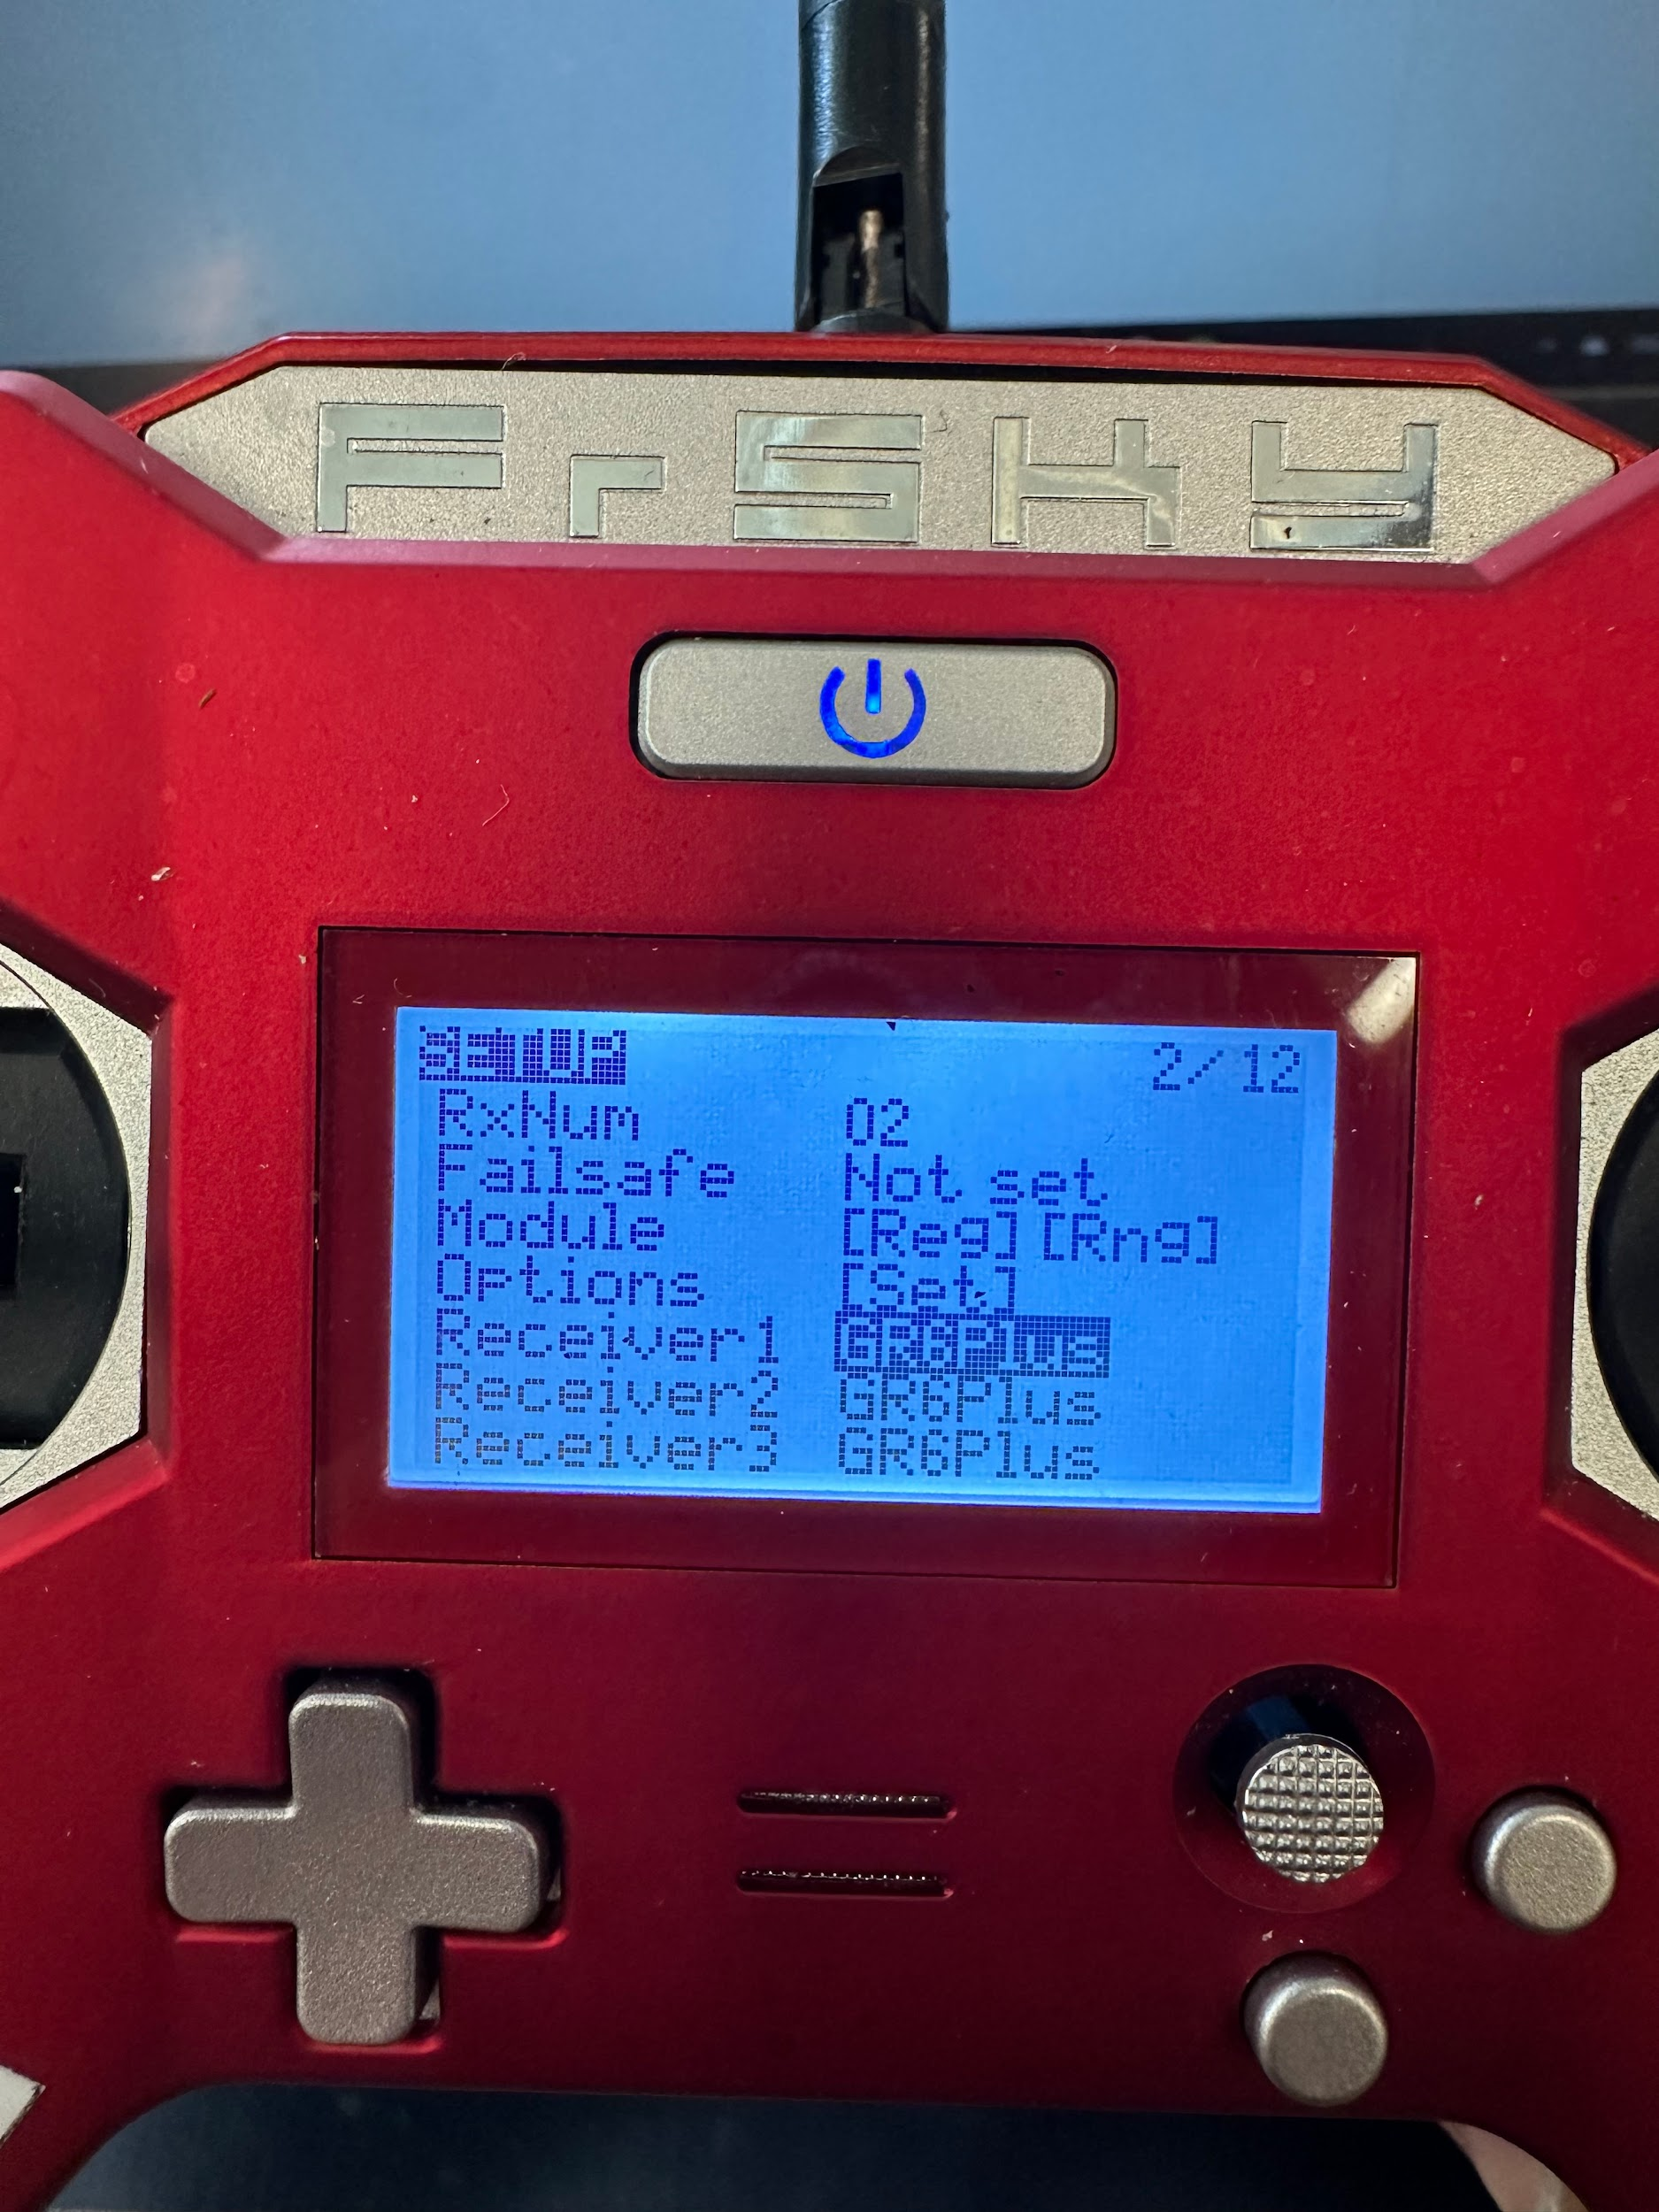

* 1. Select **Bind**

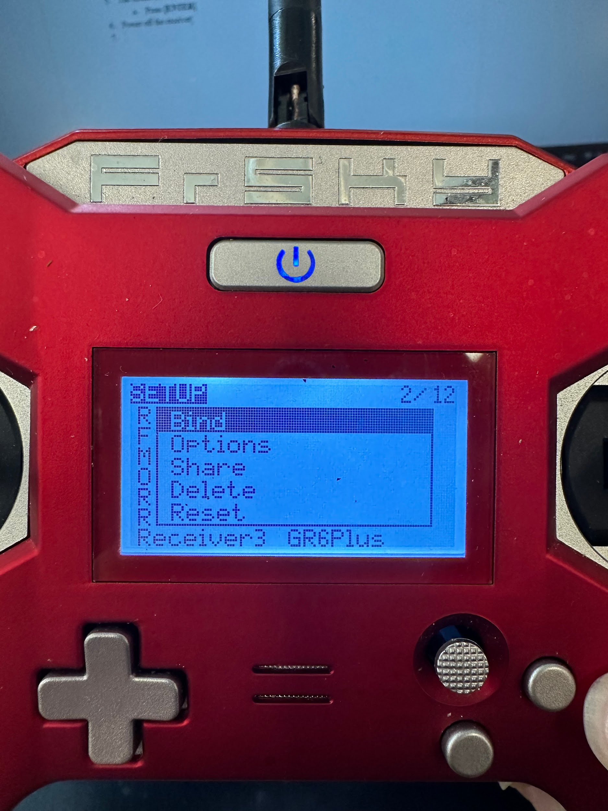

* 1. While the transmitter displays this screen, turn on the receiver WITHOUT holding down the button on the receiver

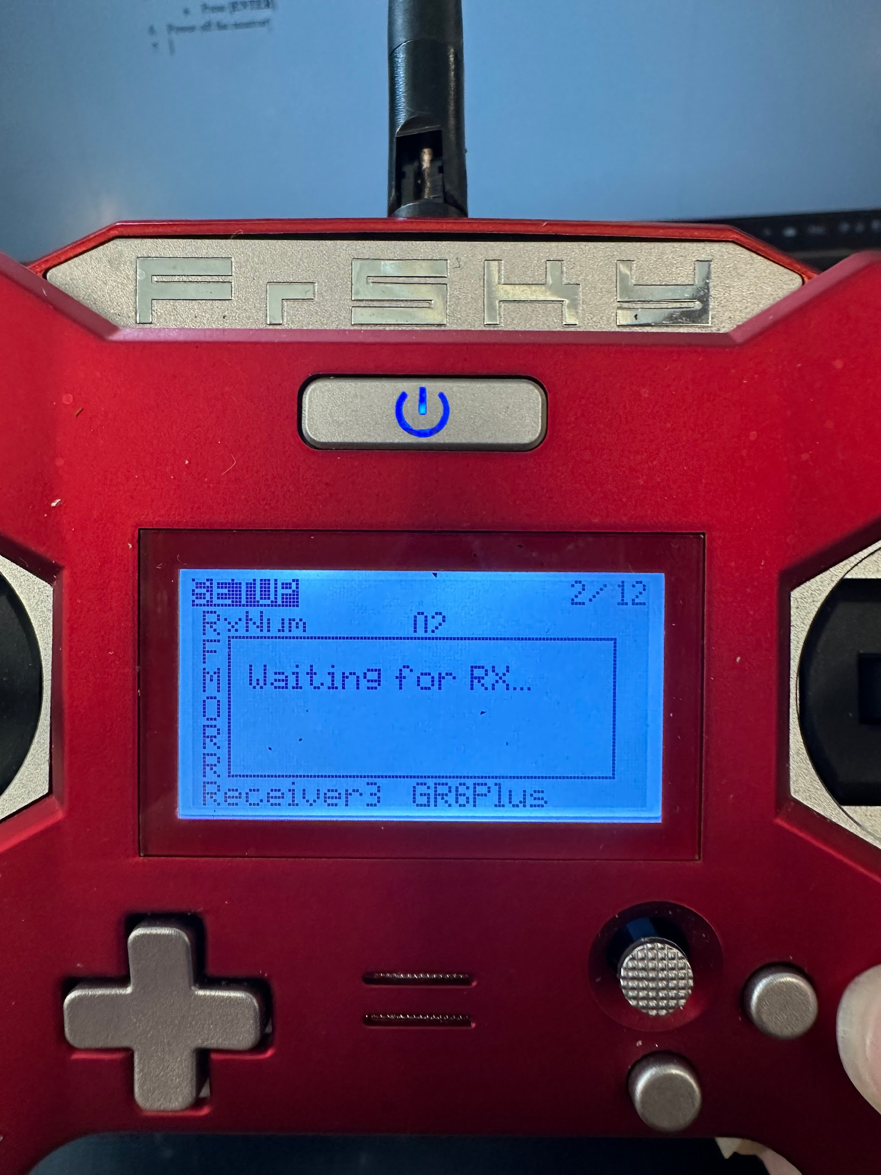

1. The screen should display a “Bind Successful” message
2. To bind multiple receivers, change the **RxNum**

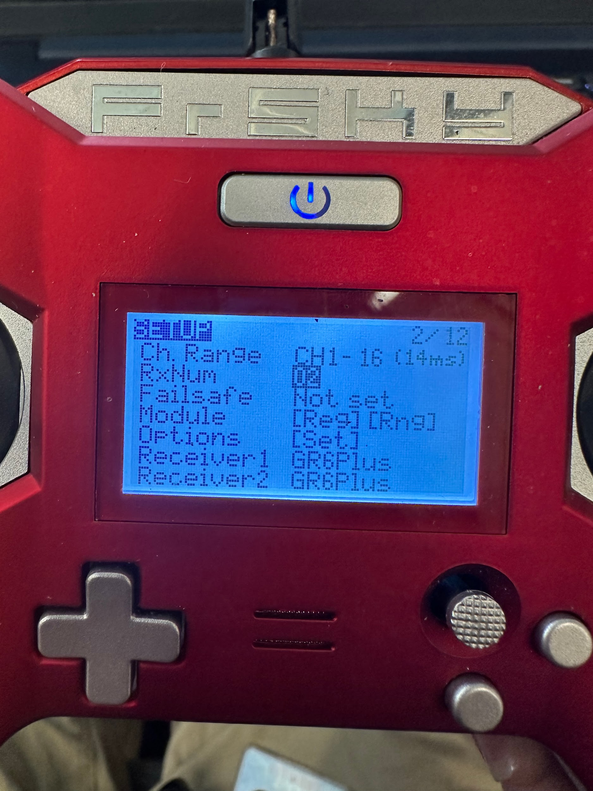

* 1. Repeat steps 3-5
  2. Substitute **Receiver 1** with **Receiver 2** in step 6
  3. Mark each receiver with its RxNum, you will need to change it based on which receiver you are using

## FlySky FS-i6

1. Plug the bind key into the receiver
2. Plug into the B/VCC channel
3. Power the receiver
4. Power on the transmitter while holding down the bind key
5. The receiver should be binded
6. The TX battery level should appear at the top right corner